**UNDERSTANDING THE COMPLEXITY OF THE CONSTRUCTION INDUSTRY, ITS CHALLENGES AND OPPORTUNITIES ‘’BY CONSIDERING THE CONCEPT OF SUSTAINABLE DEVELOPMENT**

**Table of Contents**

1.Summary- 3

2.Keyword 3

3.Introduction 4

4. Headlining Literature Review Part I With References 4

Excessive cost impact on construction business arises issues for financial resource 4

Lack of efficiency in project planning impacted negative on construction industry 5

Continuous change of financial budget impact negative on industrial productivity 6

Lack of manpower management impact as less productivity and excessive time consumption 7

Significant positive impact on construction industry by government rules and regulations 8

Installation of artificial technology and green building model increase productivity and efficiency of construction projects 9

Reference list 11

# 1.SUMMARY-

The study revolves around the concept of sustainability in the construction industry and the challenges that come while applying the sustainable development theory in construction. The construction industry is fairly complicated and has a tendency to harness or exploit resources. As the investors proceed without considering the need for sustainable development. The main purpose of the construction sector is to procure the materials and start implementing the plan and procedures of the investors. The concept of sustainable development and using sustainability in construction projects will involve the use of renewable materials and recycling all the products that have been used once on our considered as waste. This will improve the work environment and the surroundings and will and the productivity of the workers working at construction sites.

Sustainable construction methods are seen as helping the sustainable ecosystem in the business environment as they tackle environmental concerns and help utilise more resources in a safe and healthy way. This helps increase the energy association and also the pollution and use of resources such as water and fuel and manpower in an effective way. This research will discuss the factors affecting sustainable development in the construction industry along with the challenges and how the proper sustainable strategies could be implemented so that they could be helpful to businesses in solving real-life problems. Literature review part AS level opportunities and challenges of construction industry regarding cost management, leadership management, government rules and regulations and adoption of new technologies. According to cost conjunction in construction business is created in shoes by lack of budget planning without considering inflation and interest rate of project. Leadership management impact and provocatively organisational productivity however continuous change of financial budget impacted negatively on operational activities. Using of radius Technology like A>I cloud cloud-based system and green building model Improvise communication and project planning of construction industry.

# 2.KEYWORD

Issues in sustainability, dynamic elements, strategic innovation, annual growth, Internet of Things, cloud-based integration, consistency, interdependence, sustainable building, migration of workers, shortage of labour, green construction, green elements of building, prefabrication, new product innovation, sustainable development goals, pollution, carbon footprint, carbon credit rating, challenges in adoption, green accounting, renewable energies, recycling of waste materials.

# 3.INTRODUCTION

The concept of sustainability in construction means creating and using structures that are safe for the environment and they are eco-friendly. It means a lot of resources and is efficient in saving them through the life cycle of the project. This involves constructing buildings that use less energy, less water and emit less carbon which also creates less waste. The objective is to use renewable materials and energy as much as possible. A building can be made sustainable in many ways. As there is green building technology that is energy efficient and uses different appliances to reduce the overall consumption of energy the use of those materials can be seen in water conservation and reducing the energy cost. This improves the durability of the building and also helps in saving the environment.

The concept of sustainability must inculcate the value of improving the lifestyle of the people and the future generation as well by using eco-friendly methods. Working in a sustainable environment means catering to the demands of the population and also supporting the environment in the long term without affecting it in a negative way. Sustainable construction is important as it saves a lot less energy, saves a lot of raw materials and it also helps in reducing global greenhouse gas emissions and the generation of solid waste. This is why it is considered one of the optimal ways of reducing the excess number of pollutants that are emitted by construction into the atmosphere and makes our environment polluted.

The concept of sustainable development in construction is considered as it carries a lot of environmental benefits, financial benefits and social benefits as well. Using renewable sources of energy and renewable materials will help the construction industry tackle the issues of climate change and the buildings will be producing less waste and fewer carbon emissions. It also helps in minimising the cost that was otherwise spent on procuring the expensive materials for construction but green building requires less energy and less expenditure on the payment of bills as it uses solar power systems. It also has social benefits such as driving the growth of awareness among the people and it also has in maintaining a good living standard and adopting a healthy lifestyle.

# 4. HEADLINING LITERATURE REVIEW PART I WITH REFERENCES

## Excessive cost impact on construction business arises issues for financial resource

Cost and expenditure impacted on the construction industry as a financial burden because of excessive cost and expenditure impacted on net profitability by reducing margin percentage. Budget planning for construction business depends on current cost of raw materials and direct labour cost that impact on the budget of construction business because expected revenue through the project plan has been decided before starting of the construction where cost consumption in future leads to less productivity of organisation. As opined by Alaloul *et al.*  (2020), construction business is a long large object-oriented business, which conducts through cost management policies and limited time bound to deliver the project to consumers. Excessive cost impact on construction projects reduces financial resources and impacts as negative return two organisations which leads to more time consumption to complete the project.

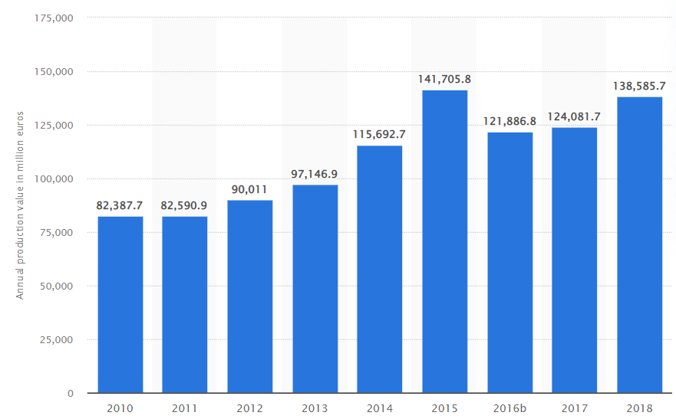

**Figure 1: Annual production cost of construction industry of UK**

(Source: Statista.com, 2022)

Cost and expenditure both are independent elements of construction projects that lead to be managed by an effective managerial decision-making approach. According to Pedro *et al.* (2019), project planning of construction has been started through master budget planning which consists of each operational activity regarding expenditure and expected potential output after completing the project plan. Due to cost and expenditure consumptions organisations impact negative operational growth that leads to less productivity in the time period. Cited by Delgado *et al.* (2019), exercise time consumption in construction business leads to excessive cost consumption regarding labour cost and machinery holding cost that impact negatively on operational profitability. Budget planning of construction business has been established by considering productivity and operational profitability growth in industrial potentiality.

## Lack of efficiency in project planning impacted negative on construction industry

Efficiency in project planning is required to maintain constant growth in construction business by improvisation of raw material labour cost management. External growth of the construction industry depending on different elements that has been impacted by inflation rate which need to be managed is average pricing methods material purchase. Efficiency in project planning depends on allocation of financial resources as per requirement whereas lack of coordination between construction operations leads to over consumption of cost to completing the project. According to Wangler *et al.* (2019), continuous growth of construction business is dependent on economic growth because of the purchasing power of customers reflected as revenue to this industry. It also helps in minimising the cost that was otherwise spent on procuring the expensive materials for construction by sufficient resource management. Economic growth deficit impacts customer pricing ability as negative that also reflect less revenue growth in construction business.

Ineffective managerial planning construction projects fail to influence dependent variables of the project plan that create financial loss to the organisation. Based on economical context, project managers need to identify economic conditions and what are the possibilities about future growth to help present a master budget for construction projects. According to statistical information of construction business contribution towards GDP is 7% that indicates positive growth opportunities for the economy. Contribution of the construction industry of the UK to GDP is £110 billion per annum that is impacted as positive growth potentiality of UK construction business (Kaplan and Haenlein, 2020). Countering the positive growth opportunity of construction business has different types of issues regarding external financial elements like interest rate and inflation rate that impact it negatively on the construction industry.

## Continuous change of financial budget impact negative on industrial productivity

Financial budget presents expected cost and expenditure of project plans along with the expected outcome of the project that determined growth options for the construction industry. Preparing a budget construction plan depends on previous cost consumption during the last period of the business plan. According to budget planning for construction, business determined possible outcomes through project plans that might be changed in future in construction projects due to the cost of interest rate and inflation. Cited by Perera *et al.* (2020), financial management team of construction business impacted on Project Planning based on inflation rate that leads to change of budgeting for future business operations. Continuous change on financial budget impacts on construction plants as vulnerable project planning for growth possibilities.

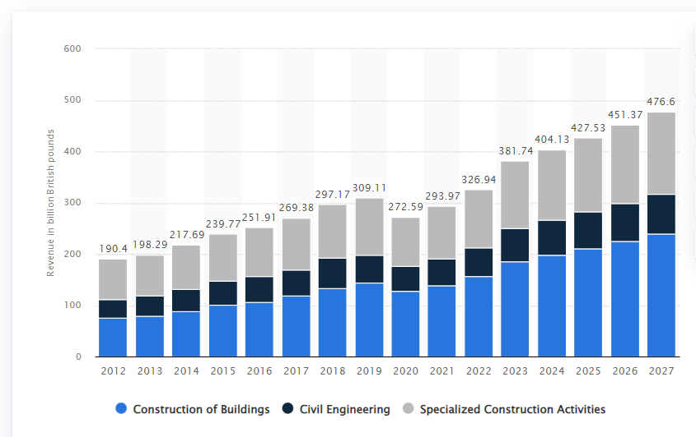

**Figure 2: Construction market revenue in United Kingdom from 2012 to 2027**

(Source: Statista.com, 2022)

Frequent change of financial budget increases cost of project plan along with excessive time consumption for completing projects. Constant growth of project planning by changing of financial budget leads to adapting new changes as per requirement of project plan that could be impacted as negative or positive to organisational profitability. Use of master budget for project planning determined actual outcome and total cost consumption of project plan were change in sales budget or operational budget less consumption of productivity growth in organisational profitability improvisation. Reduced investment in the real estate sector by investors leads to less operational financial resources and a lack of financial resources for operational benefit in the construction industry.

## Lack of manpower management impact as less productivity and excessive time consumption

Manpower management in the construction industry improvised productivity with less time consumption for each project plan. Operational benefit by manpower management construction organisation would be able to produce better productivity within conjunction of time, however lack of Manpower management in organisation also led to advance result. According to Li *et al.* (2019), human resource management in the construction industry needs to be effective because Manpower is the key to success for the construction industry. Allocation of financial resources for manpower expenditure depending on allocated funds compared with required funds for financial activities.

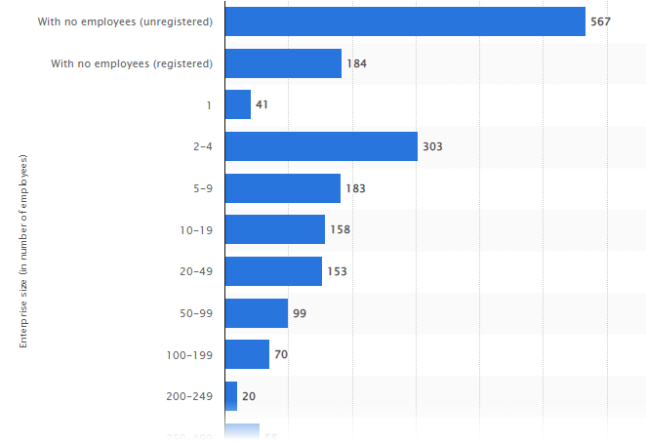

**Figure 3: Employment in construction industry**

(Source: Statista.com, 2022)

Operational activities of the construction industry have been operated through efficient allocation of Manpower for each operational activities that provide ultimate output in this organisation. Inefficient management for manpower allocation would lead to less productivity growth in operational activities through over or less allocation of manpower. Labour Law of the government also impacted on manpower management because standard time protocol for employees needs to be identified before allocation of total manpower, whereas misallocation of manpower management could lead to less productivity.

## Significant positive impact on construction industry by government rules and regulations

Government rules and regulations regarding investment in the construction industry generated more flexible options to improve productivity and business expansion. Foreign direct investment (FDI) has been controlled by government rules and regulations that have impacted Hans' financial boundaries for the construction industry. Hence, After covid-19 period, the government allowed 100% FDI investment in the construction industry to provide more financial benefit to gain effective results to produce positive business growth. Cited by Camacho *et al.* (2018), domestic investment in construction business provides Limited financial resources to organisations. The FDI investment at mode financial flexibility to process financial expansion plans for business operations that increase productivity of the construction industry after covid-19 period.

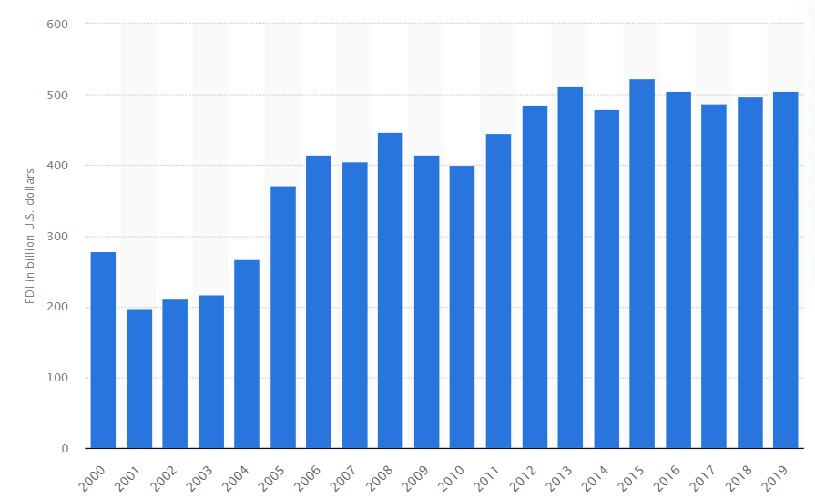

**Figure 4: Foreign direct investment (FDI) to the United Kingdom**

(Source: Statista.com, 2022)

Relaxation on labour law by the government allows the construction industry to manage the whole manpower for excessive productivity growth. Manpower laws of the UK government indicate a positive impact on the construction industry by increasing working hour per hours that indirectly improvised industrial productivity and reduced cost consumption regarding direct wages. Cited by Alaloul *et al.* (2020), increasing foreign direct investment to the UK construction industry positively for business expansion and making available working capital to produce financial flexibility.

## Installation of artificial technology and green building model increase productivity and efficiency of construction projects

Implementation of Technology in construction business improvise operational activities and helps to present operational plans with 3D projection processes that reduce communication gap between organisation and employees. AI based technologies used in construction business is to project construction plans with 3D presentation which improvise productivity along with rectification as per customer requirement. Cloud based systems provide extra leverage in communication activity that improve the operational goal of organisations through productivity improvisation of employees.

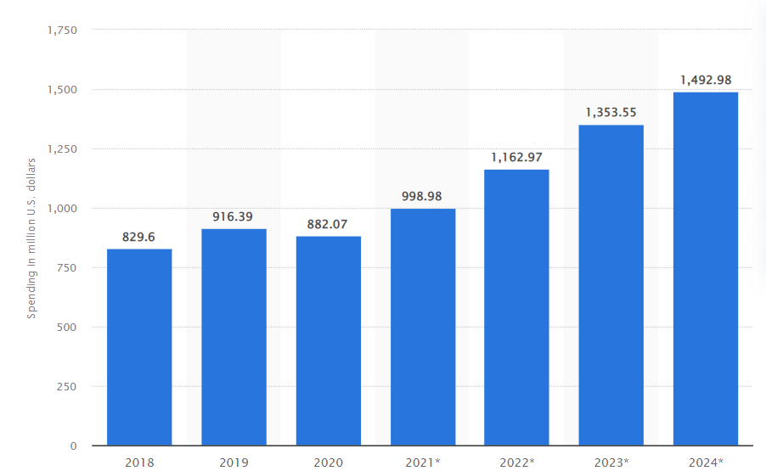

**Figure 5: Investment regarding technology in UK construction industry**

(Source: Statista.com, 2022)

Graphical presentation of investment regarding technology in the construction industry indicates continuous growth in the last 5 years which shows a positive impact on investment in the construction industry. According to statistical data fact investment regarding technology in the construction industry can identify around 70% of the total investment fund that reduces the better result of this industry. Additionally, green building models for the construction industry change the cost consumption volume that indicates more chance of profitability by operational benefits. Cited by Buchanan and Gardner, (2019), implementation of the green construction model in the construction business reduces consumption of raw material cost and also improves environmental quality through construction plans. Green building model implementation in construction business using natural resources rather than toxic materials that reduce pollution in production planning and gain beta environment conditions.

# Reference list

Alaloul, W.S., Liew, M.S., Zawawi, N.A.W.A. and Kennedy, I.B., 2020. Industrial Revolution 4.0 in the construction industry: Challenges and opportunities for stakeholders. *Ain shams engineering journal*, *11*(1), pp.225-230.

Alaloul, W.S., Liew, M.S., Zawawi, N.A.W.A. and Kennedy, I.B., 2020. Industrial Revolution 4.0 in the construction industry: Challenges and opportunities for stakeholders. *Ain shams engineering journal*, *11*(1), pp.225-230.

Buchanan, C. and Gardner, L., 2019. Metal 3D printing in construction: A review of methods, research, applications, opportunities and challenges. *Engineering Structures*, *180*, pp.332-348.

Camacho, D.D., Clayton, P., O'Brien, W.J., Seepersad, C., Juenger, M., Ferron, R. and Salamone, S., 2018. Applications of additive manufacturing in the construction industry–A forward-looking review. *Automation in construction*, *89*, pp.110-119.

Delgado, J.M.D., Oyedele, L., Ajayi, A., Akanbi, L., Akinade, O., Bilal, M. and Owolabi, H., 2019. Robotics and automated systems in construction: Understanding industry-specific challenges for adoption. *Journal of Building Engineering*, *26*, p.100868.

Kaplan, A. and Haenlein, M., 2020. Rulers of the world, unite! The challenges and opportunities of artificial intelligence. *Business Horizons*, *63*(1), pp.37-50.

Li, J., Greenwood, D. and Kassem, M., 2019. Blockchain in the built environment and construction industry: A systematic review, conceptual models and practical use cases. *Automation in construction*, *102*, pp.288-307.

Pedro, F., Subosa, M., Rivas, A. and Valverde, P., 2019. Artificial intelligence in education: Challenges and opportunities for sustainable development.

Perera, S., Nanayakkara, S., Rodrigo, M.N.N., Senaratne, S. and Weinand, R., 2020. Blockchain technology: Is it hype or real in the construction industry?. *Journal of Industrial Information Integration*, *17*, p.100125.

Wangler, T., Roussel, N., Bos, F.P., Salet, T.A. and Flatt, R.J., 2019. Digital concrete: a review. *Cement and Concrete Research*, *123*, p.105780.